Why I’m standing down from Parliament: David Heath, MP for Somerset and Frome

The last time I get to speak in the House of Commons is going to be difficult

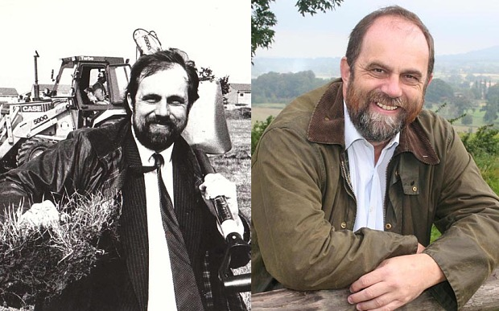

David Heath MP in 1988, and more recently

[Rosa Prince](https://www.telegraph.co.uk/journalists/)

By [Rosa Prince](https://www.telegraph.co.uk/journalists/rosa-prince/), Online Political Editor

7:30AM GMT 30 Jan 2015

[Follow](https://twitter.com/rosaprinceuk)

*The Telegraph* is speaking to MPs who are standing down at the general election in May. David Heath, 60, was Liberal Democrat MP for Somerset and Frome 1997 – 2015.

***How did you end up in Parliament?***

*At the 1985 county council elections I became, at the age of 31, the Leader of Somerset County Council, the youngest ever leader of a county council.*

*“By then the die was cast. I was effectively a full time politician. It seemed a natural transition to eventually move to national politics and Westminster.”*

***How did you feel on first becoming an MP?***

*“You arrive here, you have no office, you have no staff, you have nowhere to live. In the first weeks you think: ‘How the hell am I going to manage?’ but then you get your systems in place.*

***Best of times:***

*“I am still one of those people who gets a romantic buzz about being able to go into the chamber of the House of Commons, stand upon my feet and say what I think."*

***Worst of times:***

*“When you cease to be a minister it is very odd. You suddenly have a great deal of time on your hands and you don’t know how to fill your days."*

***Why are you leaving?***

*“I am not enjoying politics as much as I used to. It is not the House, actually I think that has improved over the last few years. It is politics, the mistrust of Members of Parliament. It’s when you sit down with a constituent and they start off by assuming you are trying to cheat them."*

***What are your thoughts for future MPs?***

*“I hope for a start that people coming into the job have some understanding of how the real world works. And take Parliament seriously, it is not just something to swing along to between radio interviews.”*

***Will you feel a pang on May 7 – and what are you going to do next?***

*“I expect so. The last time I get to speak in the House of Commons and cease to be an MP I guess is going to be difficult. I have got to pay a mortgage so I need a job. I can’t afford to retire."*

***David Heath: the full story***

David Heath grew up in Liberal country, the west of England, where although his parents were not “immensely political” he nonetheless could not help but pick up the mood in the air.

At Oxford and later City University, where he studied to become an optician, he got involved in student politics.

Returning to Somerset to practice, he ran for election to Somerset County Council in 1985 and found himself at the age of 31 the youngest ever leader of a county council – a record he believes he holds to this day.

“I realised without sounding too precious about it that I had abilities as an advocate,” he says. “Quite a vocational pull, that if you can represent people who can’t represent themselves then you ought to do it.

“Although I was trained as an optician I always realised I would end up as an advocate of sorts, whether it be in the law or politics.”

From his vantage point on the council, he was the obvious candidate ahead of the 1992 general election to fight the Westminster seat of Somerset and Frome, held by the Conservatives with a 10,000 majority.

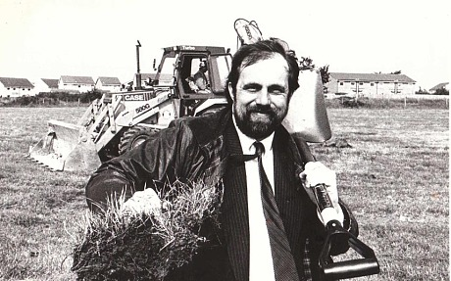

“The weekend before polling day we were very optimistic although not confident, then there was that last minute swing back to the Conservative government, so we fell a bit back.

“It was a huge ask. And probably it was a good thing to give me another four years in the real world. It increased my experience.”

Mr Heath became chairman of the local police authority and served on the Audit Commission, all the while increasing his knowledge of “the real world”.

By the time of the 1997 election he was reasonably confident of success.

“I thought it was likely,” he says. “We had serendipitous circumstances [but] I knew it was going to be tight.

“Somerset and Frome had by then become a hyper marginal [but] in ‘97 there was a distinct feeling that the time had come for a change.”

**Life as an MP**

After the usual hiccups which every new member experiences, Mr Heath settled well into life as an MP.

His summers were spent touring his constituency, one of the most beautiful parts of the country, where he made it his goal to visit more than 100 villages a year.

After serving on the council, the Commons chamber wasn’t as “scary” as it appeared to most. He began to make a name for himself as a frequent and vociferous debater.

And if the downside of being a Liberal Democrat was that – in 1997 anyway – the prospect of becoming a minister appeared remote if not impossible, one of the perks of membership of a small parliamentary party was the opportunity get involved in front bench politics sooner and at a higher level than would be expected in parties with more MPs.

Paddy Ashdown, who represented the neighbouring seat of Yeovil, and who he had known from his council days, invited him to join the Foreign Affairs Select Committee, one of the most senior in the House.

He developed an expertise in home affairs, justice and the law, while raising the “quaint” topics of interest to his constituents, such as thatched cottages and dairy farming.

But it was perhaps in the Commons chamber that he felt most at home.

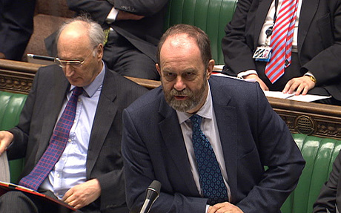

“I have always felt that I took a rather old fashioned view of being an MP, which is that I am employed to be in Parliament, standing on my hind legs, speaking out for my constituents.

“I can’t understand people who sit there in silence and troop through the lobbies.

“To me if I don’t say those things, who else is going to?”

Meanwhile, the Lib Dems were going through leaders at a rapid pace. Mr Heath was close to Mr Ashdown, who stood down in 1999, but less so to Charles Kennedy and was unaware of the scale of the drinking which would ultimately lead to his ousting in 2006.

He remains angry at what he sees as the unfair treatment dealt out by the media and the “cult of youth” during the brief leadership of Sir Menzies Campbell.

**Sacked by Nick Clegg – for the first time**

And Nick Clegg? Within a year of the new leader being elected in 2007 he had sacked Mr Heath – the first of what would turn out to be two dismissals.

The issue was the Lisbon Treaty, and Mr Heath’s determined view that the British public deserved a vote on membership of the European Union.

“I first came across Nick when he was working in Leon Britton's office in Brussels,” he says. “He came across then as being a very bright young man.

“I have always got on well with Nick [but] we had a falling out over the Lisbon Treaty. I don’t regret it, I am still absolutely clear in my mind – that is what I promised my electorate. There were three of us who took a different view, partly because of our own convictions, partly because of the strength of views in our electorate.

“I have been absolutely consistent throughout my Parliamentary career that we should have a referendum on the European Union. I am to a point Eurosceptic. I am very committed to reform of the EU. Nick said: ‘If you’re going to vote this way then we are going to have to have to part company. Perfectly respectful. No hard feelings on either side. Just a realisation that I couldn’t stay as a front bench spokesman for the party.

“It certainly wasn’t easy. I didn’t like falling out with [my] colleagues. I was sad because I did actually think the party had made a mistake.”

The estrangement was short-lived however and Mr Clegg brought him back to the front bench within a year, meaning he was in prime position to take part in the extraordinary Coalition Government formed following the indecisive outcome of the 2010 general election.

**No upside for the children of MPs**

However, although Mr Heath was still enjoying life as an MP, by 2010 his wife and had had enough and he was painfully aware of the impact his job was having on the lives of his two children.

They agreed that he would serve one last term, meaning that the prospect that he once considered almost an impossible fantasy – that he would become a minister – would come true.

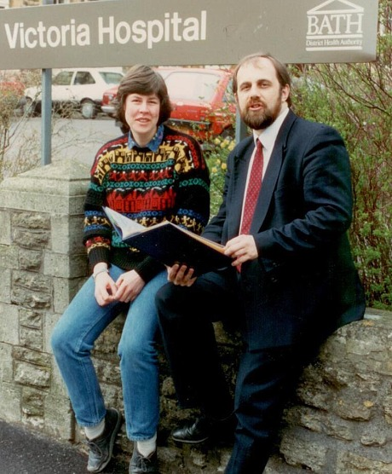

“Family had been really supportive over the years. I like to think they’re pretty proud.

“But I do think there really isn’t much upside for the children of MPs. There are no perks at all from their point of view.

“They had a reasonable amount of teasing at school. Dad’s away all week, working Fridays and Saturdays. Sundays if you’re lucky is a family day.

“Plus you can’t go around Sainsbury’s without someone stopping you and telling you their life history, which does get to you.

**Coalition Government**

“I don’t think it occurred to me that I would become a minister. That needed a certain particular chain of events to happen, for the chips to fall that way.

“When the narrative was of a two party system, with these oddities of the Liberal Democrats occasionally getting in the way, you couldn’t predict a coalition.

“It was always a possibility but it was certainly not something one would have put a lot of money on.

“Having been a local politician who had exercised power, it [was] frustrating.

“We were always buoyed up by the fact that we our influence was increasing, that we were about articulating a point of view that needed to be articulated .

“Sometimes our being at odds with what the two main parties were saying, I think we were comfortable with that role.

“It is remarkable we made the transition to government as easily as we did.”

The days following the election, as the leaders of the three main parties circled each other, were “tense”.

When the deal was finally done, and the call came from Downing Street, it was not in the circumstances Mr Heath had imagined.

He says: “I genuinely thought there was no reasonable alternative once the offer had been made. The interests of the country actually demanded we go into government and form a Coalition.

“The consequences of not doing so would have been disastrous in the short term.

“I am quite convinced that had we said no, there would have been a minority Conservative government and a second election, at which we would have had no argument. I think we would have been wiped out. I am absolutely convinced it was the only proper thing to have done. That doesn’t make it easy. I had spent my whole life in opposition to Conservatives.

“It was by no means certain I would be offered a role. I was hopeful. You always imagine that when you are offered a ministerial post it is going to be in the drawing room, and the phone will ring and a hushed voice will say ‘Hello, this is Number 10.' Actually I was at Bath Rugby watching them play Leicester Tigers at Leicester. It was just after the final whistle, Leicester won unfortunately, and there were shouting Leicester fans in the background."

Mr Heath was put into the office of the Leader of the House, serving as deputy to the Conservative Sir George Young.

With a few difficult exceptions – tuition fees, the Alternative Vote referendum and reform of the House of Lords – Mr Heath found the Coalition personally enjoyable and an overall success.

“I knew I could work with George Young,” he says. “We disagreed only twice in two-and-a-half-years, and once was over a split infinitive.

“Tuition fees was very difficult. I actually didn’t sign the infamous pledge [not to raise tuition fees, which most Lib Dem MPs promised].

“I wasn’t sure we could live up to it and I don’t like signing pledges I’m not able to live up to, but I didn’t get any credit for it. It certainly was very difficult for our activists.

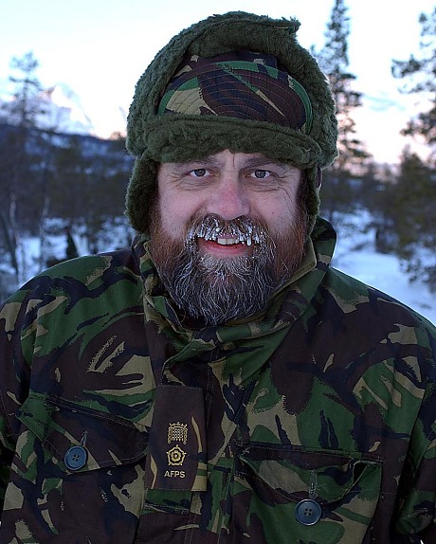

“[Ministerial life] is never dull. My honest [view] is I thought that the personal relationships in Government were much stronger than anyone could reasonably expect between two people of different parties.

“That did involve a lot of toing and froing. George and I were involved in quite a lot of troubleshooting of one sort or another [but] people within Government were working well with one another.

“The position was slightly soured when we had the AV referendum. Certainly my colleagues felt that the Prime Minister should not have allowed such personal campaigning against Nick. People were not playing fair. There was a loss of faith in the good faith of the Coalition.”

In 2012, Mr Heath was moved to the Department of the Environment, Food and Rural and Affairs, serving in his dream job as Agriculture Minister.

He enjoyed a hectic year, relishing every minute, but to his dismay was sacked 13 months later.

**Sacked for a second time**

Returning to the backbenches was hard, and cemented the tentative decision he had already taken that he would stand down at the 2015 election.

“It certainly didn’t provide a contrary argument,” he says. “I very sad to leave. I had promised my wife before I fought the last election that this would be the last one.

“She would have been happy if I had stood down at the last election but I didn’t feel I was ready.

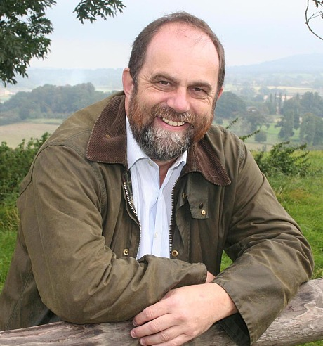

“I decided to leave about a year or so ago, I thought by now I would be regretting it deeply but the honest answer is I don’t.

“Everything that has happened since has persuaded me that I went at the right time.

“Fighting time after time in a highly marginal constituency where every time you don’t know what the outcome is going to be is hard work; nursing a constituency like that is constant pressure. Frankly there are other things you can do. I think it is time to make the break.

“I look at some of the people who are standing down at this time and it worries me that Parliament is losing a higher share of people I consider good MPs. I hope we are not driving out the best people and leaving behind those who are not so good.

“I will miss it, no doubt whatsoever. It has been a very big part of my life.”

***CV***

*Active in student politics, a qualified optician, became youngest Leader of a county council after being elected in Somerset before being selected to fight the seat of Somerset and Frome ahead of the 1992 election.*  
*1992 fights Somerset and Frome but fails to win.*  
*1997 elected MP for Somerset and Frome and appointed Foreign Affairs spokesman.*  
*1999 becomes agriculture spokesman.*  
*2001 becomes work and pensions spokesman.*  
*2003 becomes home affairs spokesman.*  
*2005 becomes spokesman for the office of Leader of the House.*  
*2007 becomes justice spokesman.*  
*2008 sacked from front bench after voting in favour of referendum on Lisbon Treaty.*  
*2009 returns to front bench in office of Leader of the House.*  
*2010 becomes Deputy Leader of the House.*  
*2012 becomes Agriculture Minister.*  
*2013 sacked as minister, returns to backbenches and announces he will not stand at the 2015 general election.*  
*Married to Caroline, two children.*